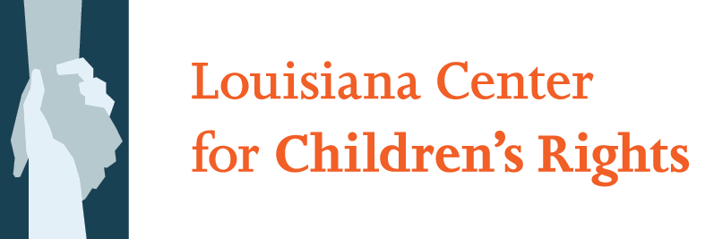

LOUISIANA CENTER FOR CHILDREN’S RIGHTS JOB DESCRIPTION:

SECOND CHANCES STAFF ATTORNEY

Organizational Overview
The Louisiana Center for Children’s Rights is a nonprofit children’s rights advocacy organization that defends the right of every child in Louisiana’s juvenile justice system to fairness, dignity, and opportunity.

Our Children’s Defense Team serves as the juvenile public defender in New Orleans, where our holistic, team-based, cross-disciplinary advocacy helps young people achieve their legal and life goals. Statewide, we provide resources and training for public defenders who work with children, and we advocate for law and policy reform to build a juvenile justice system that is fair, compassionate, and supportive of positive youth development.

Louisiana Center for Children’s Rights is an equal opportunity/affirmative action employer. Women, people of color, LGBT persons, and people with disabilities are encouraged to apply.

Project Description
The Second Chances Project of LCCR provides representation to incarcerated children post-disposition and advocates for appropriate conditions, services, and reintegration opportunities. The Second Chances Project brings the right to counsel and the promise of release and reintegration to youth in Louisiana’s juvenile custody facilities.

Through the Second Chances Project, LCCR provides holistic advocacy – including legal representation at the trial and appellate levels, case management, and the development and implementation of comprehensive service plans– for indigent youth from parishes outside of Orleans Parish who have been committed to the custody of the State of Louisiana’s Office of Juvenile Justice. The Second Chances Project’s advocacy team works to win liberty and promote successful reentry by working with clients towards fulfilling their legal and life goals.

Position Responsibilities
The primary responsibility of the Second Chances staff attorney with the Second Chances Project at LCCR is to provide high-quality legal representation for youth in all post-disposition matters, from in-custody advocacy, to modification of disposition, through reentry and parole.

More specifically, a staff attorney’s responsibilities include:

- Zealous, Client-Centered Representation
  - Advocate for the expressed interests of clients;
  - Build strong relationships of trust with clients;
  - Work collaboratively with client families to achieve client goals.

- Case Litigation
  - Represent clients in all post-disposition matters, advocating for client interests and goals in the custodial setting, such as grievances and disciplinary proceedings; as well as court appearances;
  - Develop comprehensive case strategies, taking advantage of expert assistance wherever appropriate;
  - Negotiate with facility staff and state representatives and advocate with judges and the Office of Juvenile Justice for favorable outcomes.

- Holistic Advocacy
  - Collaborate with youth advocates to implement reentry plans that account for clients’ legal and life needs like education, mental health, and housing;
  - Whenever appropriate, advocate and litigate on behalf of clients in forums outside of the courtroom, including in expulsion hearings and special education litigation.

- Administration and Projects
  - Carefully keep electronic and paper records and perform other administrative tasks as directed;
  - Supervise law clerks as appropriate;
  - Collaborate with other LCCR staff in strategic planning and implementation, and in realizing the office’s mission and vision through refinement of existing projects and new project development;
  - Join with other staff, and take the lead when appropriate, on systemic reform;
  - Assist in project evaluation and assessment;
  - Other projects as directed by LCCR’s Executive Director.

The Staff Attorney for the Second Chances Project will report to a Supervising Attorney.

Staff attorneys, like all LCCR staff, must practice law according to the highest standards of ethics and professional responsibility, and must comply with the Louisiana Rules of Professional Conduct, all regulations promulgated by the Louisiana Public Defender Board, and LCCR’s internal practice standards and protocols.

Staff attorneys will be provided with initial training and orientation and with ongoing professional development opportunities.

Required Qualifications
- Demonstrated commitment to the defense of indigent youth as a specialized practice and to LCCR’s mission, vision, goals, and values;
- Experience working as an attorney representing indigent and underserved populations;
- Excellent interpersonal and communication skills, including the ability to write persuasively and clearly and the ability to communicate with young people and their families;
- Demonstrated ability both to collaborate and work independently when necessary;
- Current good standing to practice law in Louisiana;

Preferred Qualifications
- Experience as a public defender handling delinquency matters;
- Knowledge of substantive and procedural criminal law and trial practice skills;

- Experience successfully navigating large bureaucracies or government agencies; maintaining a collaborative relationship without compromising commitments to advocate zealously for clients
- Expertise in special education law, adolescent psychology, and other areas of knowledge important for effective advocacy on behalf of youth in juvenile court.

Salary and Compensation
The position offers a competitive public defender salary, commensurate with experience. Health benefits, vacation, parental leave, and bar dues are provided. The position is full-time. No outside, compensated work is permitted.

Application Instructions:
Please include (1) a cover letter, (2) a resume or a C.V., including an email address and a daytime and evening telephone numbers; (3) a legal writing sample (4) a list of three professional references, including the name, address, telephone number and, if available, e-mail address of each.

Please do not call with inquiries. All submissions must be made via email to jobs@laccr.org. Please place “Second Chances Attorney” in the subject line of emailed submissions. Incomplete applications will not be considered.

Applications are due by October 28, 2016.

